Bansilal Ramnath Agarwal Charitable Trust’s
Vishwakarma Institute of Information Technology
(Department of Electronics & Telecommunication)



A
Project entitled

“DOOR LOCKING SYSTEM”.

Submitted by

Yash Kamate (T120393086)
Kaustubh Karlekar (T120393093)
Aditya Ketkar (T120393096)

Mini Project & Seminar

T.E. Electronics & Tele-Communication

of

University of Pune

Under the supervision of

ProR.S.Talware
(Project Guide Name)

Year 2014 – 2015

BansilalRamnathAgarwal Charitable Trust’s
Vishwakarma Institute of Information Technology
(Department of Electronics & Telecommunication)

CERTIFICATE

This is to certify that the project “DOOR LOCKING SYSTEM” has been successfully completed by

Yash Kamate
Kaustubh.Karlekar
Aditya Ketkar

It is an original work done by the students and has not been submitted previously by any other student/students for the award of any other degree of same or other university.

The work is done, on the basis of the work allotted to these students, based on various Project ideas presented by them.

This project report is being submitted as a part of the subject Mini Project and Seminar at T.E.-E&TC/T.E Electronics.

(Prof R.S.Talware.) (Dr.P.D.Khandekar.)
Project Guide H.O.D- E& TC

ACKNOWLEDGEMENT

Presenting this project would have been difficult without the guidance of Prof R S Talware. His vast experience and knowledge helped us in completing the project. We would also like to thank Prof Dr R B Ghongade for his support and motivation which boosted our confidence and helped us throughout the project. We would thank our HOD Dr.P.D.Khandekar and our college Principal Dr B S Karkare for providing all the necessary facilities.We would also thank all the teaching as well as non-teaching staff for their help and inputs at crucial times.
We would like to express gratitude towards our family and friends for their support which helped us make this project a success. It was a great learning experience which brought us close to practical implementation of our knowledge. It introduced us to various softwares used in the industry and gave us exposure to industry practices.

Yash.Kamate.
Kaustubh.Karlekar.
Aditya.Ketkar.

INDEX

Sr. No | Contents | Page No.
1. | INTRODUCTION
2. | BACKGROUND
3. | BLOCK DIAGRAM
4. | ELECTRONIC AND HARDWARE DESIGN ASPECTS
5. | SOFTWARE ASPECTS
6. | CIRCUIT DESIGN
7. | SIMULATION RESULTS
8. | PCB LAYOUT
9. | TESTING OF MODULES
10. | CABINET DESIGN AND ASSEMBLY
11. | BILL OF MATERIALS
12. | REFERENCES
13. | PROJECT PHOTO
14. | CONCLUSINON
15. | DATA SHEETS

1.INTRODUCTION

Many times we forget to carry the key of our home. Or sometimes we come out of our home and door latch closes by mistake. In these cases it is really difficult to get inside the house. This project is designed to solve this purpose. Main concept behind this project is of a door-latch opening using a password entered through keypad. As well as turning on the Buzzer when password is entered wrong for multiple times. User can change this password anytime he/she wish using a keypad.
This project is basically designed to provide a full proof security to a room/home/confidential area allowing only authorized personnel to enter the same. It is done through a numeric password & a microcontroller associated with an alarming circuitry. The following project does not focus on Automation on door operation; rather provides a sophisticated way of securing a particular area.
The microcontroller based Door locker is an access control system that allows only authorized persons to access a restricted area. The system is fully controlled by the 8 bit microcontroller PIC18F4520 which has a 32KB of ROM for the program memory. The password is stored in the EPROM so that we can change it at any time.
The system has a Keypad through which the password can be entered. When the entered password equals with the password stored in the memory then the relay gets on and so that the door is opened. If we enter a wrong password for more than three times then the Alarm is switched on.

2.BACKGROUND
Traditional lock systems using mechanical lock and key mechanism are being replaced by new advanced techniques of locking system. These techniques are an integration of mechanical and electronic devices and highly intelligent. One of the prominent features of these innovative lock systems is their simplicity and high efficiency. Such an automatic lock system consists of electronic control assembly which controls the output load through a password. This output load can be a motor or a lamp or any other mechanical/electrical load. Here we develop an electronic code lock system using PIC microcontroller, which provides control to the actuating the load. It is a simple embedded system with input from the keypad and the output being actuated accordingly. This system demonstrates a password based door lock system wherein once the correct code or password is entered, the door is opened and the concerned person is allowed access to the secured area. Again if another person arrives it will ask to enter the password. If the password is wrong then door would remain closed, denying the access to the person.

3.BLOCK DIAGRAM

4.HARDWARE DESIGN ASPECTS

4.1 MICROCONTROLLER SELECTION:
Parameter | PIC16F688 | PIC16F877 | PIC18F4520
Pin Count | 14 | 28/40 | 28/40/44
Operating voltage | 2V – 5.5V | 2V – 5.5V | 2V – 5.5V
Operating frequency | 0 to 20MHz | 0 to 20MHz | 0 to 40MHz
Inbuilt ADC | 8 | 8 | 13
ADC bits | 10 | 10 | 10
No of timers(8/16) | 1/1 | 3/0 | 1/3
Prog Memory | 4K | 8K | 32KB
Data memory | 256(SRAM),256(EEPROM) | 368(SRAM),256(EEPROM) | 1536(SRAM),256(EEPROM)

From this comparison we are selecting the PIC18F4520 microcontroller as it is satisfying our project requirements such as high pin count, data memory, EEPROM .

4.2 RESET CIRCUIT:
We are connecting an RC circuit to the MCLR (pin1) of the microcontroller (18f4520).The resistor value from the datasheet is 4.7kohm. The PIC has an active low reset.

4.3 CRYSTAL CIRCUIT:
Here we are connecting two capacitors which are basically of values 100pF each. In other words to give a pure square wave to the microcontroller. Basic rule for placing the crystal on the board is that it should be as close as possible to avoid any interference in the clock.

4.4 POWER BUDGET:
CURRENT REQUIREMENTS OF VARIOUS COMPONENTS
PIC18F4520 =25mA
LCD =50mA
LM7805 =5mA
Resistors = 22*8
=176 mA
Latch =1A
LM317 =5mA
Relay =35mA*2
=70mA
Total current =1.3*2
=2.6A
Approx=3A

VOLTAGE REQUIREMENT = 5V,12V
Total power require=1.5W (for 5V), 12W (for 12V)

5. SOFTWARE DESIGN ASPECT
5.1 MikroC

For the designing of the whole software part of this project we have used MikroC software. The MikroC software combines project management, make facilities, source code editing, program debugging, and complete simulation in one powerful environment. This platform is easy-to-use and allows for such software to be written in C programming language and to be simulated on computer before loading onto the microcontroller.

5.1.1 Algorithm:
Steps-
- Select mode (identify or learn)
- Learn mode:- using one light source at a time record the output of phototransistor for each source.
- Use these values as a database for identify mode.
- Identify mode:- using the same sequence of light sources as in learn mode record the output for each wavelength.
- Compare the values in identify mode those found in learn mode.
- According to these values display the identified fluid name on LCD.

5.2 PROTEUS (VERSION 8.0)
ISIS provides the development environment for PROTEUS VSM revolutionary interactive system level simulator. This product combines mixed mode circuit simulation, microprocessor models and interactive component models to allow the simulation of complete micro-controller based design. ISIS provides the means to enter the design in the first place, the architecture for real time interactive simulation and a system for managing the source and the object code associated with each project. In addition the number of graph objects can be placed in the scematic to enable conventional time, frequency and swept variable simulation to be prformed.

5.3 Altium designer (13.2)
Altium designer software was used for PCB designing. Altium Designer is productivity focused electronics design software for professionals, incorporating unified stress-free schematic and Printed Circuit Board CAD functions with design verification, validation and formal release and reuse capabilities. Altium Designer is powerful and flexible, making it much easier to do highly constrained PCB designs faster. By keeping the schematic and PCB in sync, all design domains share a common interface increasing usability and reducing effort.

6.Circuit Diagram
a)Door Locking System

b)Linear Power Supply

- SIMULATION RESULT
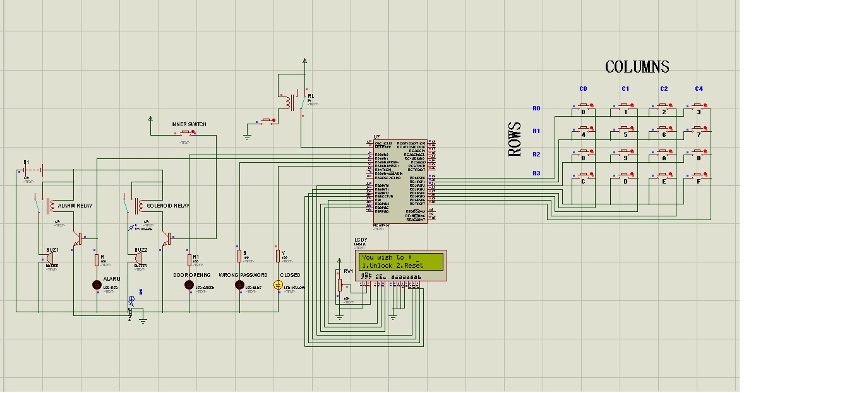

8.PCB LAYOUT
a)Door Locking System (Main PCB

b)Linear Power Supply (PCB)

9.TESTING

1. Testing of continuity : The PCB tracks were checked for continuity after the fabrication.
2.Testing of power supply : We tested output of our power supply IC(LM7805),IC(LM317) using Multimeter.
3.Testing of led: a)Checking blinking of led's
b)Checking turn on and turn off time as per given in programs.

4.Testing of Solenoid Latch: Solenoid Latch was checked by giving supply 12V & 1A current through LPS.

11. BILL OF MATERIALS

12. CONCLUSIONS
- This project provides security at comparatively low cost.
- Power consumption is less.
- Use of commonly available components.
- Project is simple and highly customizable.

13. REFERENCES
1. http://www.electronicshub.org/password-based-door-lock-system
2. http://www.projectsof8051.com/password-based-door-locking-system/

